Major：Computer Science Class：2022
Student ID No. | 2022380085 |  | Name |  | CLAUDIUS REGINALDI ETANIA |  |  | Advisor |  |  | 杨波
Title of  the Thesis |  | Research on Deep Learning-Based Skin Disease Image Classification Method
Topic Source  （mark “√”） |  | □Practical Teaching |  | Integration of Science and Education |  |  | □Innovation and Entrepreneurship |  | □Integration of Industry and Education | □International Co-operation |  | □Post-  graduate project
Thesis Type（mark “ √”） |  | Engineering Design |  |  |  | □Theoretical Research /Theoretical Thesis |  |  |  | □Others
Date of Report |  | 2026/01/23 |  |  |  |  |  | Place of Report |  | Online Report, Tencent Meeting No. 242-801-302
Proposal Report（no less than 1000 words）
Research on Deep Learning-Based Skin Disease Image Classification Method

- Background, significance and basis of the topic
  - Background
Skin diseases are among the most common health problems worldwide and pose a significant risk to human health. Many skin conditions, including infectious diseases, inflammatory disorders, and malignant lesions, can seriously affect a patient’s quality of life and, in severe cases, may become life-threatening if not treated in a timely manner. As the skin is the body’s largest and most exposed organ, it is vulnerable to environmental factors such as UV radiation, pollution, and microbial infection. In recent years, the incidence rate of skin diseases has shown a clear increasing trend. Factors such as lifestyle changes, aging populations, environmental pollution, and prolonged exposure to electronic devices have contributed to the growing number of dermatological cases. This rising incidence places increasing pressure on medical systems and highlights the need for efficient and accurate diagnostic tools. Early detection and treatment are particularly important for skin diseases. Many conditions, especially pigmented lesions and malignant skin tumors, have a higher cure rate when diagnosed at an earlier. Delayed or incorrect diagnosis may lead to disease progression, increased treatment difficulty, and poorer clinical outcomes. Therefore, improving diagnostic efficiency at the early stage is of great value. However, diagnosing skin diseases remains
challenging because many different conditions have very similar visual symptoms, such as redness, pigmentation, scaling, or irregular lesion boundaries. Even experienced dermatologists may find it difficult to differentiate certain diseases only by naked eyes. This similarity increases the risk of misdiagnosis and motivates the development of intelligent, computer-aided diagnostic methods based on deep learning and medical image analysis.
  - Research Basis
This study is based on existing theories and methods in deep learning, computer vision, and medical image processing. Numerous studies have shown that deep learning, especially convolutional neural networks, has strong capabilities in image analysis and has been successfully applied to various skin disease diagnosis tasks. These methods can automatically learn discriminative features related to lesion color, texture, and structure, which are closely related to the visual characteristics used in clinical diagnosis. In addition, recent research indicates that multimodal learning plays an important role in improving diagnostic performance, as different imaging modalities provide complementary information. For example, RGB clinical images mainly describe surface appearance, while Wood’s lamp and other specialized imaging modalities reveal subsurface pigmentation and fluorescence characteristics that are difficult to observe under normal lighting conditions. Attention mechanisms and feature fusion techniques have further improved the effectiveness of multimodal models by aligning heterogeneous features and highlighting lesion-related information. Moreover, the availability of public skin disease image datasets and widely adopted evaluation metrics provides a reliable experimental foundation for model training, validation, and performance comparison. These existing theories, methods, and resources together form a solid research basis for this thesis.
- Research status at home and abroad
2.1 Multi-Modality Feature Learning for Classification
Multimodal feature learning has become a central direction in skin disease classification because a single imaging modality often cannot capture all clinically relevant lesion cues. Conventional RGB clinical photos provide surface color, texture and boundary information, while other modalities. for example dermoscopy, Wood’s-lamp imaging, or VISIA multi-illumination channels reveal subsurface pigmentation, fluorescence and illumination-specific contrasts that are invisible under standard lighting. Studies on melasma and other pigmentary disorders show that fusing multiple imaging modes (multi-illumination VISIA channels) yields substantially higher diagnostic accuracy and AUC than single-mode inputs [1]. Work that fuses skin images with clinical metadata or patient records (image + non-image fusion) similarly demonstrates consistent performance gains, indicating that complementary non-visual information is often diagnostically useful [2,3]. Architectures that explicitly exchange information across modalities. for example, multi-scale information-switching networks that pass shallow and deep features between branches have been shown to improve recognition when lesion cues appear at different spatial scales [4]. Recent multi-label and multimodal studies further confirm that richer cross-modal interaction produces more robust representations for complex dermatologic tasks [5].
Building on these results, several applied studies provide practical design patterns that inform this thesis. Smartphone-based multimodal pipelines demonstrate the value of keeping modality encoders separate and fusing at the feature level rather than at the decision stage [3]. Multimodal fusion investigations also highlight the need to model both shared (correlated) and modality-specific (complementary) information a point made explicit by adversarial fusion approaches that align shared features while preserving complementary details via attention-guided reconstruction [6]. These findings directly motivate the dual-branch design adopted here (RGB branch + Wood’s-lamp branch), feature-level fusion, and experiments comparing image-image and image-metadata fusion strategies.
2.2 Attention Mechanism
Attention mechanisms are widely used in medical imaging to guide networks toward lesion-relevant signals and away from distracting background such as hair, shadows or specular highlights. Lightweight convolutional attention modules perform well inside CNN backbones: channel-reweighting modules (Squeeze-and-Excitation) boost informative channels, spatial attention modules highlight lesion regions, and combined channel–spatial modules such as CBAM and BAM produce compact and effective gating that is simple to insert into ResNet/VGG blocks [7–9]. These modules are attractive when computational cost is a concern because they add minimal overhead while improving localization and feature quality.
At a higher level, transformer-style self-attention computes pairwise relationships across image tokens and captures long-range context that CNNs can miss; Vision Transformer (ViT) variants and windowed transformers (Swin) have been successfully applied in vision tasks to model global structure [10,11]. Cross-attention extends this idea to multimodal fusion by allowing queries from one modality to attend to keys/values from another, effectively enabling modality A to selectively import complementary cues from modality B. Practical dermatology studies use both lightweight convolutional attention inside modality encoders and transformer-inspired cross-attention at the fusion stage: attention-guided encoders improve lesion focus while cross-attention modules materially improve fusion quality in multimodal pipelines and enable efficient collaborative/edge inference in deployment scenarios [3,6,12]. For this thesis, a hybrid approach is recommended: use SE/CBAM blocks inside CNN backbones for efficient intra-modality focus, and a small cross-attention module at the fusion point to permit explicit modality interaction when resources allow.
2.3 Feature Fusion
Feature fusion determines how modality-specific encodings are combined into a single representation and has a major impact on robustness and generalization. Simple element-wise operations (addition/multiplication) are efficient but risk losing modality-specific cues when feature distributions differ. Concatenation preserves raw information and lets subsequent layers learn integration, but it places heavy burden on those layers to discover cross-modal correspondences. Attention-based fusion — particularly cross-attention — outperforms naïve methods for heterogeneous modalities because it allows one modality to query and weight the most relevant features from another, improving interpretability and discrimination [12]. Hybrid strategies that add adversarial alignment or reconstruction losses further strengthen fused representations by encouraging modality-invariant signals while preserving complementary details; AM-FAM and related works show that this hybrid approach yields higher AUC and better robustness to modality noise [6].
In addition, multi-scale fusion or information-switching — where shallow and deep features are exchanged across branches — is effective when lesions exhibit features at different scales (texture vs global shape). The practical recommendation for this thesis is to implement a simple concatenation baseline, a cross-attention fusion module, and a hybrid fusion variant that includes light adversarial alignment or reconstruction loss; comparative experiments and ablation studies will determine the best trade-off between accuracy, robustness and computational cost on the chosen public datasets.
- Research objectives, contents, methods and key technologies
  - Research objectives (concise, measurable)
- To analyze and compare lesion characteristics across different skin imaging modalities.
This study aims to investigate how different imaging modalities, such as conventional RGB imaging and dermoscopic or Wood’s lamp imaging, describe lesion features from different perspectives. By analyzing the complementary information provided by each modality, the study seeks to clarify their respective roles and contributions in representing skin disease characteristics.
- To design and implement a deep learning–based skin disease classification method.
Leveraging the powerful feature extraction capabilities of convolutional neural networks and attention mechanisms, this research aims to construct a multimodal deep learning framework capable of effectively learning complex lesion features and performing accurate skin disease classification based on image data.
- To evaluate the proposed method using public dermatological image datasets.
The proposed model will be tested and validated on publicly available skin disease image datasets, such as PUMCH-ISD and Derm7pt, using standard evaluation metrics. This objective ensures the effectiveness, robustness, and generalization ability of the proposed approach.
  - Research contents (work packages)
- To study the characteristic description of lesions by different modes of skin disease imaging. For specific skin lesions, different imaging modalities, such as conventional optical imaging and dermoscopy, can reflect different information and characteristics of the lesion area. These characteristics can be used for the diagnosis and differentiation of the disease. This study investigates the ability of different modalities of skin imaging to represent the disease.
- Research and implement an image-based method for classifying skin diseases. Leveraging the ability of deep learning to describe complex features and models, this study proposes to construct a deep learning classification network for multimodal skin disease images using convolutional neural networks and attention mechanisms, thereby enabling the identification and classification of skin diseases based on images.
- The method was tested and evaluated using a public dataset of dermatological images. We plan to use public dermatology image datasets, such as PUMCH-ISD and Derm7pt datasets, to test and evaluate the proposed methods.
3.3 Research methods and key technologies (summary)
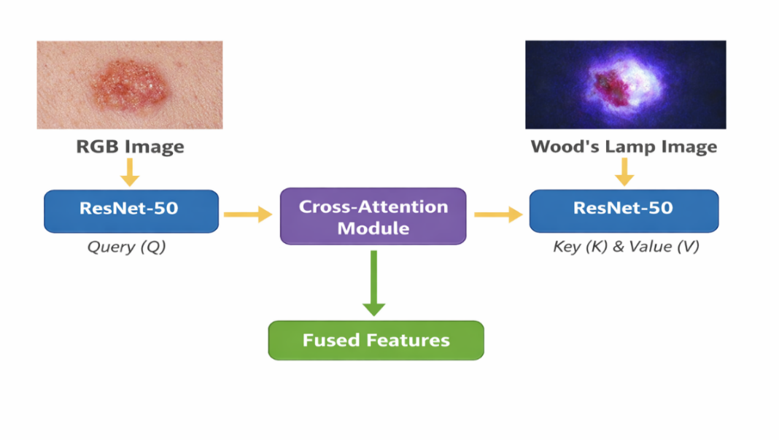
(1) Multimodal Network Architecture for Skin Disease Diagnosis
Fig.1 Two Branch Network Input
Skin disease diagnosis often requires information from different imaging modalities to capture both surface and subsurface characteristics of lesions. Therefore, this study adopts a multimodal learning framework that integrates two complementary image modalities: RGB clinical images and Wood’s lamp images. RGB images in Fig.1 provide visual information such as color, texture, and lesion boundaries, while Wood’s lamp images reveal fluorescence patterns and subsurface skin features that are difficult to observe under normal lighting conditions. The joint use of these modalities enables more comprehensive representation of skin disease characteristics.
In the proposed framework, each modality forms an independent network branch, resulting in a dual-branch architecture. RGB images and Wood’s lamp images are input into two parallel deep convolutional neural networks with identical backbone structures, such as ResNet-50. This design allows each branch to learn modality-specific features while maintaining structural consistency across the network. By separating the feature extraction process at the early stage, the network preserves the unique information of each modality and avoids premature feature mixing.
(2) Feature fusion
To combine information from RGB images and Wood’s lamp images, this study designs a backbone feature strategy using ResNet-18, ResNet-50, and VGGNet. RGB and Wood’s lamp inputs are processed through parallel backbone networks to get complementary features. ResNet-18 captures low-level texture features with low computational cost, ResNet-50 extracts high-level semantic features through deep residual learning, and VGGNet provides fine-grained spatial representations.
The extracted features are aligned and mixed using an attention-guided strategy, enabling adaptive weighting of features from different backbones and modalities. This fusion approach enhances feature diversity and efficiency, improving the accuracy of skin disease classification.
To enhance the network’s ability to focus on discriminative lesion features and model interactions between different feature sources, an improved cross-attention–based attention mechanism is designed.
Given two feature representations—such as image features $F_{\text{img}}$and auxiliary features $F_{\text{aux}}$(e.g., metadata or features from another scale)—the cross-attention mechanism is defined as:
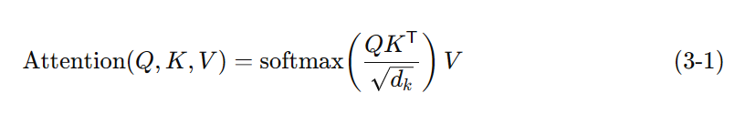

(1)

Where $Q=F_{\text{img}}W_{Q}$represents the query matrix, $K=F_{\text{aux}}W_{K}$represents the key matrix, $V=F_{\text{aux}}W_{V}$
represents the value matrix, $W_{Q},W_{K},W_{V}$are learnable projection matrices, and $d_{k}$is the dimension of the key vectors.
In the proposed feature fusion module, a cross-attention mechanism is used to fuse multimodal features extracted from RGB images and Wood’s lamp images. In Eq.1 the query matrix $Q$is generated from the feature representation of one modality, while the key $K$and value $V$matrices are derived from the complementary modality. The scaled dot-product operation measures the similarity between features from different modalities, and the softmax function converts these similarities into attention weights. By weighting and aggregating the value features, the model emphasizes complementary and disease-relevant information while suppressing redundant or noisy features. This cross-attention–based fusion enables effective interaction between multimodal features and improves the discriminative capability of the final representation for skin disease classification.
Through this mechanism, image features selectively attend to relevant auxiliary features, enabling the model to capture correlated and complementary information across feature sources. The output of the cross-attention module is then combined with the original image features via residual connections to preserve spatial information. This attention mechanism allows the network to emphasize lesion-related regions and suppress irrelevant background information, thereby improving feature representation and classification performance in skin disease image analysis.
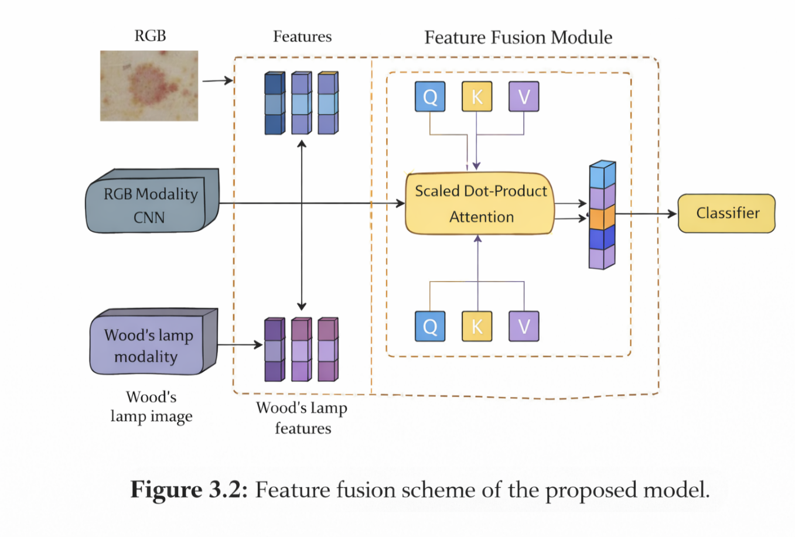
Fig. 2 Multimodal Feature Fusion Framework Based on Dual-Branch Network

(3) Experimental validation
Datasets and General Description
To validate the effectiveness of the proposed multimodal skin disease diagnosis method, experiments are conducted using publicly available skin disease image datasets. These datasets mainly include RGB clinical images of skin lesions, and some samples are accompanied by auxiliary imaging modalities, such as Wood’s lamp or dermoscopic images, which are commonly used in clinical diagnosis.
The datasets cover multiple types of skin diseases with varying visual characteristics, including differences in color, texture, shape, and lesion boundaries. The RGB images provide surface-level information, while Wood’s lamp images highlight fluorescence and subsurface skin features. All images are preprocessed through resizing, normalization, and data augmentation to reduce overfitting and improve generalization. The datasets are divided into training, validation, and test sets to ensure objective and fair performance evaluation.
Evaluation Metrics
To comprehensively evaluate the performance of the proposed model, several standard metrics widely used in medical image analysis and object detection tasks are adopted, including Precision, Recall, F1-score, and mean Average Precision (mAP).
Let TP (True Positive) denote the number of correctly predicted positive samples, FP (False Positive) denote the number of incorrectly predicted positive samples, FN (False Negative) denote the number of missed positive samples, and TN (True Negative) denote the number of correctly predicted negative samples.
Precision measures the correctness of positive predictions:

$$\text{Precision}=\frac{TP}{TP+FP} (2)$$

Recall measures the ability of the model to identify all positive samples:

$$\text{Recall}=\frac{TP}{TP+FN} (3)$$

F1-score is the harmonic mean of Precision and Recall, providing a balanced evaluation of classification performance:

$$\text{F1-score}=\frac{2×\text{Precision}×\text{Recall}}{\text{Precision}+\text{Recall}} (4)$$
Average Precision (AP) is calculated as the area under the Precision–Recall curve for a single class.
Mean Average Precision (mAP) is the average of AP values across all classes and is defined as:
$$\text{mAP}=\frac{1}{N}\sum_{i=1}^{N}{A}P_{i } (5)$$
where $N$represents the total number of disease categories.
Experimental Evaluation Strategy
Based on the above datasets and evaluation metrics, the proposed multimodal framework is quantitatively evaluated. Comparative experiments and ablation studies are conducted to analyze the impact of multimodal inputs and different backbone networks on model performance, thereby verifying the effectiveness and robustness of the proposed method
4. Possible difficulties and problems, possible solutions, and the objectives of the research (ALL PARAGRAPH)
- Differences Between RGB and Wood’s Lamp Images (Paragraph)
RGB images and Wood’s lamp images differ substantially because they are captured under different lighting and imaging conditions, which makes it difficult for a model to combine their information directly; to address this, the proposed method employs attention-based feature fusion so the network can automatically focus on the most informative cues from each modality, and the objective of this approach is to enable the model to better understand and effectively integrate complementary features from RGB and Wood’s lamp images.
- High Model Complexity
Using multiple backbone networks such as ResNet-18, ResNet-50, and VGGNet increases model size and complexity, which can slow training and raise the risk of overfitting; to mitigate these issues the design will selectively choose backbones based on a trade-off between capacity and efficiency, apply data augmentation and regularization techniques during training, and the objective is to build a model that maintains high classification accuracy while remaining computationally practical.
- Class Imbalance and Similar Appearance of Skin Diseases
Class imbalance and the visual similarity of many skin diseases make classification challenging because some categories have far fewer training samples and lesions from different classes can appear very similar; the proposed solutions include balanced sampling strategies, improved loss functions (for example focal loss or class-weighting), and attention mechanisms that help the network focus on discriminative lesion features, with the objective of improving the system’s reliability and generalization across rare classes and visually ambiguous cases.
- Research schedule
January 11 – January 24 (2026)
Topic confirmation, thesis proposal preparation, and overall research planning. Collection of relevant literature on skin disease diagnosis, deep learning, multimodal learning, and attention mechanisms.
January 25 – February 7(2026)
In-depth literature review focusing on CNN-based models, multimodal skin imaging, and existing diagnostic methods. Clarification of research objectives, methods, and technical route.
February 8 – February 21 (2026)
Dataset investigation and preparation, including data organization, preprocessing, and augmentation for RGB and Wood’s lamp images.
February 22 – March 7 (2026)
Design and implementation of the multimodal dual-branch network architecture. Selection and configuration of backbone networks such as ResNet-18, ResNet-50, and VGGNet.
March 8 – March 21 (2026)
Implementation of feature fusion strategies and integration of multimodal features into the overall framework. Preliminary model training and debugging.
March 22 – April 4 (2026)
Model optimization and parameter tuning. Conduct comparative experiments using different backbone networks and input modalities.
April 5 – April 18 (2026)
Experimental evaluation using defined metrics such as Precision, Recall, F1-score, and mAP. Analysis of results and ablation studies.
April 19 – May 2 (2026)
Organization of experimental results and discussion of findings. Writing of core thesis chapters, including methodology and experimental analysis.
May 3 – May 19 (2026)
Thesis revision, formatting, and final proofreading. Preparation for thesis submission and defense.
- References (volume and page number)
[1] Li, Y., et al., An Intelligent Diagnostic Model for Melasma Based on Deep Learning and Multimode Image Input, Computers in Biology and Medicine, 2021, 135:2-6.
[2] Zhang, Y., et al., Adversarial Multimodal Fusion with Attention Mechanism for Skin Lesion Classification Using Clinical and Dermoscopic Images (AM-FAM), IEEE Trans. Medical Imaging, 2022. 41: 8 pp. 2150 – 2157.
[3] Ou, C., et al., A Deep Learning Based Multimodal Fusion Model for Skin Lesion Diagnosis Using Smartphone-Collected Clinical Images and Metadata, (journal article in your files), 2022. 26:11 pp. 5466 – 5427.
[4] Tran-Van, N.-Y., Le, K.-H., A Multimodal Skin Lesion Classification through Cross-Attention Fusion and Collaborative Edge Computing, IEEE JBHI / CMIG (2023/2025). 27:9 pp. 4304 – 4310.
[5] Deep Multi-Modal Skin-Imaging-Based Information-Switching Network for Skin Lesion Recognition (MDSIS paper), 2022. 78, pp. 4 -10.
[6] Wang, H., et al., MDFNet: Application of Multimodal Fusion Method Based on Skin Image and Clinical Data to Skin Cancer Classification, Biomedical Signal Processing and Control, 2022. 74, pp. 3-8.
[7] Zhang, X., et al., A Novel Perspective for Multi-Modal Multi-Label Skin Lesion Classification, Winter Conference on Applications of Computer Vision (WACV), Feb 28–Mar 4, 2025, Tucson, AZ, USA, pp. 3549–3558.
[8] He, K., Zhang, X., Ren, S., Sun, J., Deep Residual Learning for Image Recognition (ResNet), Computer Vision and Pattern Recognition (CVPR), June 27–30, 2016, Las Vegas, Nevada, United States, pp. 770–778.
[9] Hu, J., Shen, L., Sun, G., Squeeze-and-Excitation Networks (SE), Computer Vision and Pattern Recognition (CVPR), June 18–22, 2018, Salt Lake City, Utah, United States, pp. 7132–7141.
[10] Woo, S., Park, J., Lee, J.-Y., Kweon, I.-S., CBAM: Convolutional Block Attention Module, European Conference on Computer Vision (ECCV), Munich, Germany, Sept 8–14, 2018. Lecture Notes in Computer Science (LNCS), ECCV 2018, pp. 3–19.
[11] Park, J., Woo, S., Lee, J.-Y., Kweon, I.-S., BAM: Bottleneck Attention Module, (arXiv/ conference workshop), 2018.
[12] Vaswani, A., et al., Attention Is All You Need, NeurIPS 2017. pp. 5998–6008.
[13] Dosovitskiy, A., et al., An Image Is Worth 16×16 Words: Vision Transformer (ViT), International Conference on Learning Representations (ICLR), May 3–7, 2021, Virtual Conference (originally planned in Vienna, Austria),
pp. 1–21.
[14] Esteva, A., et al., Dermatologist-Level Classification of Skin Cancer with Deep Neural Networks, Nature 2017. 542 (7639): 115–118 (2017).
[15] Codella, N. C. F., et al., ISIC/ISBI skin lesion analysis challenges (2017–2019), IEEE TMI/challenge proceedings. “Skin Lesion Analysis Toward Melanoma Detection” (ISBI / ISIC challenge reports; e.g., arXiv:1710.05006).
[16] Baltrusaitis, T., Ahuja, C., Morency, L. P., Multimodal Machine Learning: A Survey and Taxonomy, IEEE Transactions on Pattern Analysis and Machine Intelligence (TPAMI) 2019. 41(2): 423–443.

Opinion of the Advisor：




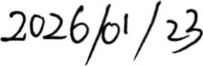
Signature：
Date: (YYYY/MM/DD)
The Proposal Assessment Team：

陈建忠、陈小锋、杨波


